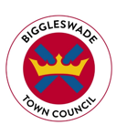
BIGGLESWADE TOWN COUNCIL
Public Realm Operative
Salary £20,043 to £22,129 per annum (SCP 6-11)
37 hours per week, variable working hours
Biggleswade Town Council are seeking to appoint a Public Realm Operative to join a dedicated Public Realm Team.
The role is an exciting opportunity to work on a variety of projects and provide excellent community services to Biggleswade.
Biggleswade is a thriving, and rapidly expanding, market town within the Central Bedfordshire area and serves a population of over 21,000.
Biggleswade Town Council currently provides a wide range of services to the community, including Public Open Spaces, Parks, Tennis Courts, Cemeteries, Allotments and Community Buildings. Furthermore, Biggleswade holds a Charter Market and a variety of community events within its Town Centre.
This is a varied and interesting role which will involve:
- Working alongside the Public Realm Chargehand and Public Realm Manager in maintaining specified elements of the Council’s services.
- Undertaking a variety of horticultural and grounds maintenance activities including grass mowing, planting, leaf clearance, strimming, litter picking, weeding, hedge cutting and minor tree works through the proper use of manual, chemical and mechanical methods.
- Managing a range of maintenance and cleansing activities to Public Open Spaces, horticultural features, highway verges, car parks, formal parks, public toilets, sporting facilities, play areas and other Public Realm areas including streets and rights of way.
Experience in a similar role is essential. The successful candidate will have a knowledge of horticulture, buildings and grounds maintenance.
For a full Job Description and Person Specification please visit our website: www.biggleswadetowncouncil.gov.uk

In order to apply for this role, please email your CV to: enquiry@biggleswadetowncouncil.gov.uk
Or post your CV to: Biggleswade Town Council, The Old Court House, 4 Saffron Road, Biggleswade, SG18 8DL.
Closing date: Monday 30th May 2022, 9am
Interviews: w/c 6th June 2022
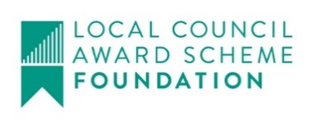
For an informal discussion please contact: Jonathan.Woolley@biggleswadetowncouncil.gov.uk

