BIGGLESWADE TOWN COUNCIL
Assistant Caretaker
Salary £13,576 to £14,989 per annum (SCP 7-12)
25 hours per week, variable working hours
Biggleswade Town Council are seeking to recruit an Assistant Caretaker to look after the cleanliness of the Orchard Community Centre, the Town Council offices and the Century House public toilets.
This is a varied and interesting role which will involve:
- To share key holder responsibilities and flexible working hours according to requirements.
- Cleaning the Orchard Community Centre.
- Cleaning the Town Council offices and the Century House public toilets.
- Supervising the Orchard Community Centre premises, looking after the smooth running of the use of the rooms, events & functions, liaising with hirers.
- Preparing areas within the Community Hall for use by hirers, setting up seating, tables, and equipment as required.
- Clearing up after events and functions, returning equipment to their stored position.
- Assisting in minor maintenance work within the Council’s premises and facilities.
Experience in a similar role is essential. The successful candidate will have a knowledge of building cleaning procedures, materials and equipment, and an ability to communicate with staff and visitors.
For a full Job Description, Person Specification and Application Form please contact:

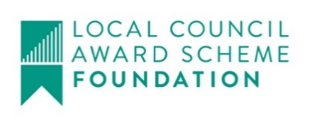
Biggleswade Town Council, The Old Court House,
4 Saffron Road, Biggleswade, Beds, SG18 8DL.
Tel: 01767 313134
Email: enquiries@biggleswadetowncouncil.gov.uk

Or visit Biggleswade Town Council’s website: https://biggleswadetowncouncil.gov.uk/vacancies/

Closing date for applications: Monday 8th November 2021, 5pm

