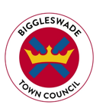
BIGGLESWADE TOWN COUNCIL
Public Realm Operative
Salary £19,698 to £21,748 per annum (SCP 6-11)
37 hours per week, variable working hours
Biggleswade Town Council are seeking to appoint a Public Realm Operative to join a dedicated Public Realm Team.
The role is an exciting opportunity to work on a variety of projects and provide excellent community services to Biggleswade.
Biggleswade is a thriving, and rapidly expanding, market town within the Central Bedfordshire area and serves a population of over 21,000.
Biggleswade Town Council currently provides a wide range of services to the community, including Public Open Spaces, Parks, Tennis Courts, Cemeteries, Allotments and Community Buildings. Furthermore, Biggleswade holds a Charter Market and a variety of community events within its Town Centre.
This is a varied and interesting role which will involve:
- Working alongside the Public Realm Chargehand and Public Realm Manager in maintaining specified elements of the Council’s services.
- Undertaking a variety of horticultural and grounds maintenance activities including grass mowing, planting, leaf clearance, strimming, litter picking, weeding, hedge cutting and minor tree works through the proper use of manual, chemical and mechanical methods.
- Managing a range of maintenance and cleansing activities to Public Open Spaces, horticultural features, highway verges, car parks, formal parks, public toilets, sporting facilities, play areas and other Public Realm areas including streets and rights of way.
Experience in a similar role is essential. The successful candidate will have a knowledge of horticulture, buildings and grounds maintenance.
For a full Job Description, Person Specification and Application Form please visit our website: www.biggleswadetowncouncil.gov.uk

Closing date for applications: Friday 23rd July 2021, 5pm
Interviews w/c 2nd August 2021
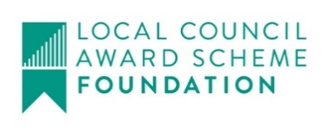
For an informal discussion please contact: Jonathan.Woolley@biggleswadetowncouncil.gov.uk

