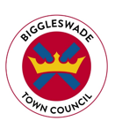
BIGGLESWADE TOWN COUNCIL
Public Realm Chargehand
Salary £23,080 to £24,491 per annum (SCP 14-17)
37 hours per week, variable working hours
Biggleswade Town Council are seeking to appoint a Public Realm Chargehand to join and manage a dedicated Public Realm Team.
The role is an exciting opportunity to work on a variety of projects and provide excellent community services to Biggleswade.
Biggleswade is a thriving, and rapidly expanding, market town within the Central Bedfordshire area and serves a population of over 21,000.
Biggleswade Town Council currently provides a wide range of services to the community, including public open spaces, parks, tennis courts, cemeteries, allotments and community buildings. Furthermore, Biggleswade holds a Charter Market and a variety of community events within its Town Centre.
The Council also holds the Local Council Award Scheme at Foundation level.
This is a varied and interesting role which will involve:
- Working alongside the Public Realm Manager in managing specified elements of the Council’s services.
- Providing a clear instruction to staff and managing the Public Realm Team in a way which derives maximum benefit from flexibility of labour within a well-developed and empowered group.
- Managing a range of maintenance and cleansing activities to Public Open Spaces, horticultural features, highway verges, car parks, formal parks, public toilets, sporting facilities, play areas and other public realm areas including streets and rights of way.
Experience in a similar role is essential. The successful candidate will have a knowledge of horticulture, buildings and grounds maintenance.
For a full Job Description, Person Specification and Application Form please visit our website: www.biggleswadetowncouncil.gov.uk

Closing date for applications: Friday 23rd July 2021, 5pm
Interviews w/c 2nd August 2021
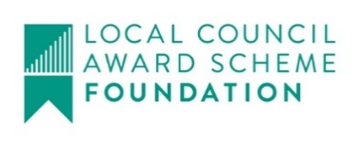
For an informal discussion please contact: Jonathan.Woolley@biggleswadetowncouncil.gov.uk

